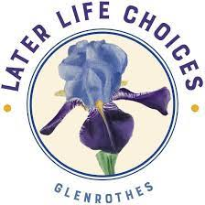

Table of Contents
Table of Contents
Executive Summary
1. Later Life Choices Glenrothes4

  - Overview
  - Purpose, Vision and Core Values
  - Service Provision
  - Organisation
  - Client Profile: Demographics and Demands
  - Stakeholder Engagement
2. Reflective Analysis
  - Overview
  - External Analysis
2.2.1. PESTLE Analysis
  - Internal Reflection
2.3.1. SWOT Analysis
  - Strategic Responses
2.4.1. TOWS Analysis
3. Strategic Goals and Evaluation
  - Overview
  - Strategic Priorities
  - Strategic and Evaluative Decision-Making Framework
4. Conclusion
  - Summary
5. Annexes
  - Annex A: Client/Carer Survey Insights
  - Annex B: PESTLE Analysis Template
  - Annex C: SWOT Analysis Template
  - Annex D: TOWS Analysis Template

Executive Summary

This strategic plan sets out the intended strategic direction for Later Life Choices Glenrothes (LLCG) over the period 2022-2027. It follows on from the updated 2021 strategic plan that reflected the impact of the COVID-19 pandemic and the changing care environment. This new plan was developed by an external consulting firm, FreshSight, and endorsed by the Board at its meeting on 23 March 2022.

The primary objective during the last strategic period was to remain solvent amidst the uncertainty created by the pandemic. This objective was achieved and now LLCG can begin to look to the future once again.

As Scotland recovers from the pandemic, LLCG faces unprecedented pressures from constricting funding sources to mounting demand for care services. LLCG was able to reinstate its services during Autumn 2021, although significant adaptations are still in place to help facilitate them. Considering this, it is critical that LLCG updates its strategic plan to reflect and help navigate the extraordinary circumstances.

  - This plan provides a roadmap to help LLCG accomplish its mission and support the Board and Management to make decisions and achieve action. It dissects LCCG’s strategic priorities to offer practical links to projects and emphasises evaluation processes.

  - The strategic plan is a living document, intended to support management ad demonstrate to all LLCG’s stakeholders why it exists and what it aims to achieve. It fits into a collection of documents including a funding database and budgeting tool as a comprehensive toolkit for guiding and supporting LLCG and its stakeholders.

Later Life Choices Glenrothes

Overview
    - This section of the strategic plan discusses LLCG, its mission and values, services, organisational structure, client profile and approach to stakeholder engagement.

Purpose, Vision and Core Values
Purpose: Our purpose clearly defines our mission and role in supporting older people in the Glenrothes area.
PURPOSE

TO PROVIDE SERVICES FOR OLDER PEOPLE AND THEIR CARERS IN GLENROTHES, AND THE SURROUNDING AREA, THAT ENHANCE THEIR QUALITY AND ENJOYMENT OF LIFE BY ENCOURAGING INTERACTION, MENTAL AND PHYSICAL ACTIVITY AND COMPANIONSHIP. OUR AIM IS TO PROMOTE INDEPENDENCE, IMPROVE CONFIDENCE AND REDUCE SOCIAL ISOLATION, BY PROVIDING A CHOICE OF SERVICES THAT REFLECT THE ASPIRATIONS AND REQUIREMENTS OF EACH INDIVIDUAL AND THEIR CARERS WHERE POSSIBLE.

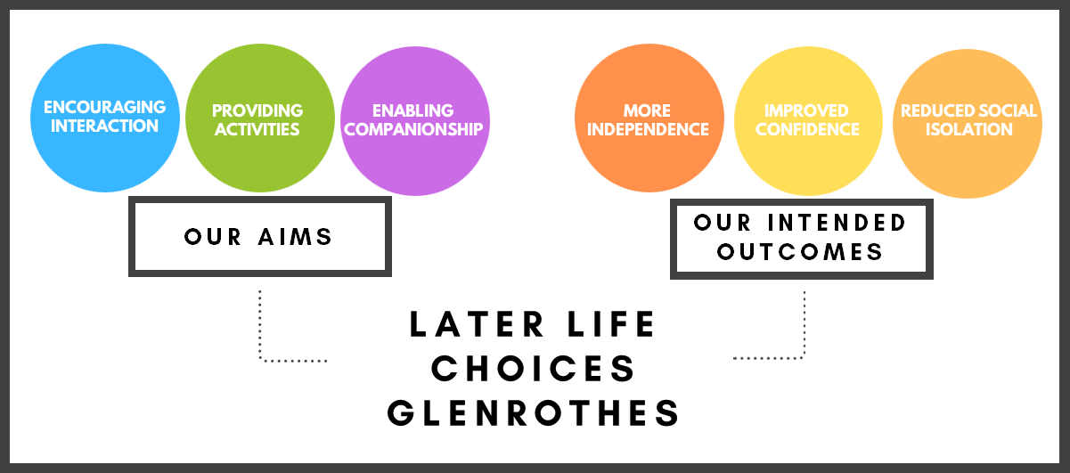
ENCOURAGING
INTERACTION
PROVIDING ACTIVITIES
ENABLING COMPANIONSHIP
MORE
INDEPENDENCE
IMPROVE CONFIDENCE
REDUCED SOCIAL ISOLATION

Vision: Our vision outlines how we intend to achieve our mission.
VISION
TO MAINTAIN VIABLE, SUSTAINABLE AND RELEVANT SUPPORT SERVICES TO OLDER PEOPLE AND THEIR CARERS IN THE GLENROTHES AREA TO HELP THEM LEAD
ACTIVE AND VALUED LIVES
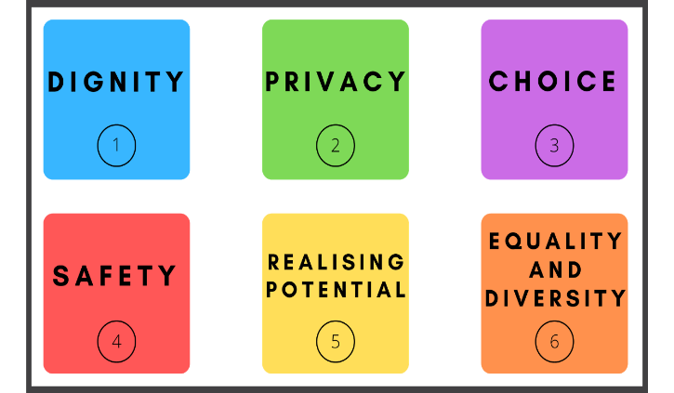
1.2.3. Core Values: Our core values represent what we stand for and are the standards we hold ourselves to. LLCG’s core value are outlined below:
LLCG respects and promotes an individual’s right to:
- Dignity: To always be treated with dignity and respect and to enjoy a range of social relationships.

- Privacy: To have their privacy and property respected, and receive the time, space and facilities needed and desired as long as it is safe for themselves and others.

- Choice: To make informed choices, whilst recognising the rights of other people to do the same. To know about the range of choices available. To access help to fully understand all options and make a choice that is right for themselves.

- Safety: To feel safe and secure within the service, promote independence, be free from exploitation and abuse. Such an environment will assist in promoting health and wellbeing and enjoyment of the LLCG experience.

- Realising Potential: To maximise achievement, make full use of the resources that are available, to make the most of their life.

- Equality and Diversity: To live an independent life, rich in purpose, meaning and personal fulfilment. To be valued for their ethnic background, language, culture and faith and to be treated equally. To live in an environment free from bullying, harassment and discrimination and to be able to complain effectively without fear of victimisation.

Service Provision
    - The services provided by LLCG are early intended to be intervention and preventative, promoting independent lifestyles for needy older people living in their own homes. The organisation provides a low-cost support service that utilises the diverse skills of staff and volunteers, delaying the need for more costly services. LLCG is dedicated to working in partnership with the Fife Health and Social Care Partnership as well as other healthcare practitioners including GPs, CMHNs and Post Diagnostic Team Area Coordinators.

    - Before the pandemic, our mission was achieved by services in support of Fife’s Health and Social Care Partnership. During the pandemic, none of these services were practicable, so alternative services were created. These varied depending on the lockdown status at any particular time or any changes to our sponsor’s requirements.

    - As Scotland starts to recover from the pandemic, LLCG has reinstated most of its services, albeit with restrictions on group capacity and travel arrangements. These are:

SERVICES PROVIDED
Active Ageing
1
Dementia Support
2
Help to Stay at Home
3

- Active Ageing: An Active Ageing service, providing support in line with Fife Council's Active Ageing Day Service model. This support includes supporting people who are living with dementia;
- Dementia Support: Support to older people who are living with dementia;
- Help to Stay at Home: One-to-one inhouse visits lasting one or two hours The visits provide tailored support as a preventative measure at the point where there is a potential need for long-term care or hospital admission. This service can support people to access their local community, and provide befriending and assistance with practical tasks and hobbies.

Organisation
    - LLCG employs a team of dedicated staff with joint managers providing overall control of services and people management. LLCG’s overall direction and oversight is maintained by the Board of Directors.

    - Staff were supported by an enthusiastic team of volunteers, but Covid limitations have temporarily prevented LLCG from including their invaluable contribution. As legal restrictions ease and associated health concerns fall away, LLCG is now seeing volunteers returning and more older people coming back to sessions.

    - The structure of the organisation reflects the resources needed to support the clients in the most cost-effective way. These resources will change as needs and demands evolve.

Client Profile: Demographics and Demands
    - The 2019 Fife Health and Social Care Strategic Plan states that 20% of people in Fife are aged 65 years or older. It is estimated that the 75 and over age group will increase by 35.1% by 2026 compared to 2017.

    - A recent survey indicates that feelings of isolation and feelings of anxiety are increasingly becoming issues influencing the lives of LLCG clients.

    - This dynamic, alongside Covid, is creating a situation where more older people will need support, but in circumstances where funding availability will likely be limited. Consequently, LLCG needs to determine how it can maximise the available funding to effectively reach the rising demand.

Stakeholder Engagement
    - LLCG maintains strategic links with our partners and sponsors to deliver services that accord with their priorities. We have sought the views of the Fife Social Care Partnership in preparing this updated Strategy Plan.

    - We administered a client/carer survey during November 2021 to update and refine our understanding of the needs of clients and how LLCG forms part of their lives, especially following Covid. The key data is represented in charts in Annex A.

    - Stakeholder comments help inform strategic priorities and subsequent planning.

Reflective Analysis

Overview
    - Identifying strategic priorities and creating goals that ultimately progress our mission requires critical reflection on LLCG and the environment we operate within.

    - This section discusses the tools used to structure our approach to analysis and devising initial responses from it. These tools are PESTLE Analysis and SWOT Analysis. Together, they help create a TOWS Matrix to better inform strategic priorities and planning. Each tool is explained in their respective section.

    - Each analysis will be updated annually to maintain its relevance. The existing templates used to perform the analysis are included in Annexes B, C and D.

External Analysis
    - LLCG operates in a space heavily impacted by external factors. The most obvious one recently has been the pandemic, but there are other considerations like LLCG’s dependency on external inputs – particularly funding.

    - LLCG are already aware of most of these factors, however we have explicitly identified them to better inform strategic planning and development.

    - The framework used to help achieve this is called a PESTLE Analysis. This breaks down the external opportunities and risks into six factors: Political (P), Economic (E), Social (S), Technological (T), Legal (L) and Environmental (E).

    - The current (end of 2021) analysis is presented below:

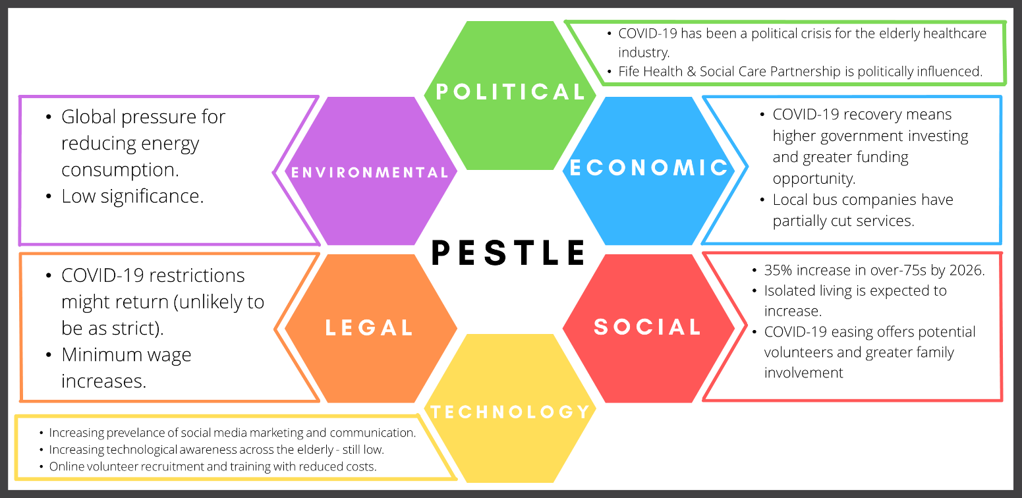
- Increasing social media marketing & communication.
- Increasing technological awareness across older people – still low.
- Online volunteer recruitment & training with reduced costs.

    - Summary: LLCG’s most significant external influences are the economic, social and legal factors. They pose the greatest risk/opportunity for LLCG. It is likely that this will remain the case throughout this strategic period, but it is crucial that we monitor the external environment and incorporate any potentially impactful circumstances into our strategic planning.

Internal Reflection
    - The strengths (S), weaknesses (W), opportunities (O) and threats (T) analysis (SWOT) is a framework that supports evaluation of an organisation’s position and direction.

    - It provides a breakdown of key elements specific to LLCG and must be used by management to inform decision-making. The most recent one (end of 2021) is presented below:
 | STRENGTHS  - High quality service  - Solid reputation with funders  - Effective and committed staff and support volunteers  - Strong standing in the community  - Connections with carersenhance services to  - Impressive response to Covid 19 impacts  - Support from clients  - Rebranding is more positively framed than before  - Robust value creation for accessing funding  - Key assets in premises and minibus |  |  | WEAKNESSES  - High workload for staff  - Costly items (eg transport, training)  - Inadequate premises for increasing demand  - Inability to service expanding demand  - Limited engagement between staff and Board  - No structured fundraising plans  - Exposed management structure  - Potential disruption to client services when staff sick or on leave  - Insufficient marketing  - Current strategic plan is hard to implement and evaluate  - Reliance on core funding  - Deficit making
 | OPPORTUNITIES  - Community includes many organisations, like schools  - Many clients use other services too  - Rebranding presents opportunity raising LLCG’s profile  - Enhance services to meet clients’ developing needs  - Societal focus on older people healthcare services  - Growing older population in Fife  - Reducing Covid 19 restrictions  - Enables travel  - Family involvement  - Technology-based training and qualification schemes  - Inexperienced young people  - Many potential funding sources |  |  | THREATS  - Annual funding timeline restricts mid-term planning  - Sponsor policies are liable to change  - Unexpected infrastructure investment through faults or safety issues  - Ageing staff and volunteers  - Potential for competition from future new organisations  - Covid 19  - Reduced numbers of volunteers  - Public transport routes have been cut, reliance on LLCG  - Restrictions might return  - Minimum/living wage increase squeezes costs  - Low appetite for technology integration from clients despite likely increasing need
SWOT ANALYSIS
    - Summary: LLCG are currently well-positioned to develop and expand as Scotland continues to recover from the pandemic. There are, however, significant weaknesses within the organisation that risk being exacerbated by the threats LLCG faces. It is critical that the specifics of the SWOT Analysis are included in all strategic decision-making.

Strategic Responses
    - Combining the PESTLE and SWOT Analyses and resulting observations enables more focused planning and decision-making processes as strategies become easier to identify and structure.

    - This has been carried out using the TOWS Matrix. This approach relates the external and internal analysis of an organisation to support exploring and evaluating strategic options. It considers leveraging strengths (S) to seize opportunities (O) and mitigate threats (T) whilst also using opportunities to overcome weaknesses (W).

    - The current (end of 2021) analysis – simplified within this document – is presented below:

TOWS MATRIX

 | STRENGTHS L E V E RAGE OPPORTUNITIES  - Reputation and client demand can enable partnerships and collaborative projects with organisations (age or otherwise)  - Use community standing to build social media presence  - Use reputation and need for volunteers to attract young volunteers who need work experience (market it as such)  - Develop initiatives to reconnect clients with their families |  |  | OPPORTUNITIES  OVE RCOMING WEAKNESS  - Use internet schemes to support training and qualifications and reduce costs  - Use marketing projects and particularly social media, to attract young volunteers to help develop a stronger “brand” and management team. Consider part-time marketing coordinator  - Use reputation, rebranding and community standing to promote LLCG, raise funds and spread financial risk  - Use reputation to access low cost/free premises  - Reassess premises utilisation  - Link with similar organisations to explore how to hold events together to save money, learn how they fundraise, and manage themselves. advertise themselves and reach the community
 | STRENGTHS MIT IGAT ING  THREAT S  - Potential for other funding sources enables midterm planning and reduces impact of policy changes  - Use reputation and need for volunteers to attract young volunteers who need work experience (market it as such)  - Consider agreements with taxi companies to help reduce costs and pressure on LLCG  - Scenario plan proactively to help guide LLCG during another lockdown |  |  | MINIMISING WEAKNESSES  AND THREATS  - Include some staff, clients and/or carers in management and board meetings  - Restructure approach to management and project implementation  - Deliberate on funding options to spread risk and fill deficit  - Consider external cleaning company/ make cleaning part of volunteering duties to reduce impact of minimum/living wage increases  - Despite current lack of appetite, technology use in older people is growing. Towards the end of the strategic plan period, it might be possible to utilise and create new services and channels

    - Summary: The analysis has already prompted many initial ideas, with the potential for many more. This matrix can then be used to help identify strategic priorities, specify objectives and breakdown necessary resources.

Strategic Goals and Evaluation

Overview
In previous strategic plans, we have outlined our strategic priorities to help focus our planning. However, we recognise that this approach is limited in implementing strategies.

Whilst we strive for our overall mission, it is vital that strategic objectives are kept grounded and more specific to support decision-making and planning. This means better defining and specifying our goals and breaking down projects into more tangible actions for management, staff and volunteers to follow.

Crucially, we have expanded our evaluation approach to help drive LLCG and our representatives towards the strategic objectives and, ultimately, our mission. Evaluation must be a core focus of any strategic planning and requires deliberation and discussion in how it is achieved.

As such, we have developed a framework for structuring our priorities and implementing evaluation measures. The entire framework is in another document.

Strategic Priorities
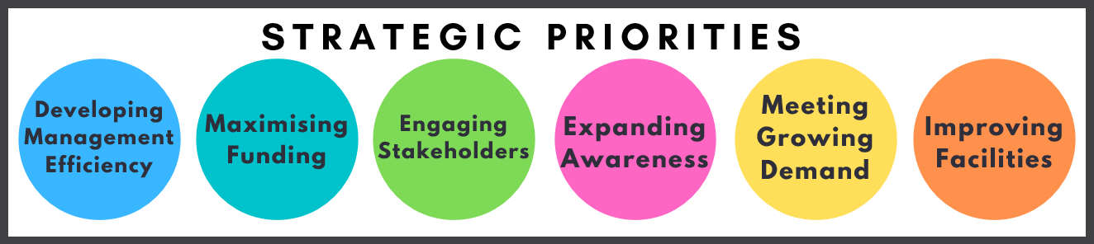
Due to the pandemic, our strategic priorities remain largely unchanged from the previous strategic period. These are:

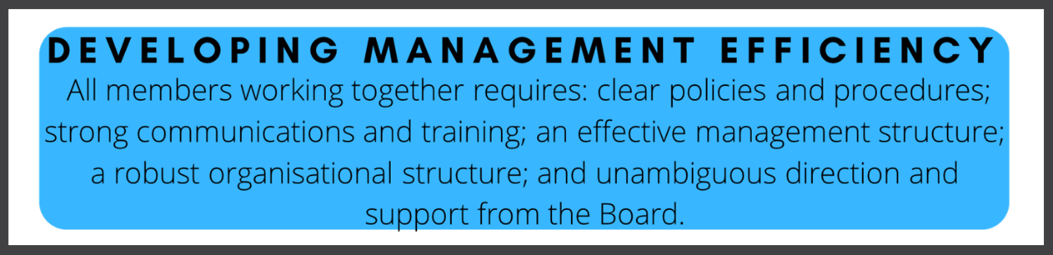
All strategic priorities are discussed in further detail within the framework alongside other likely considerations. However, they are summarised here:

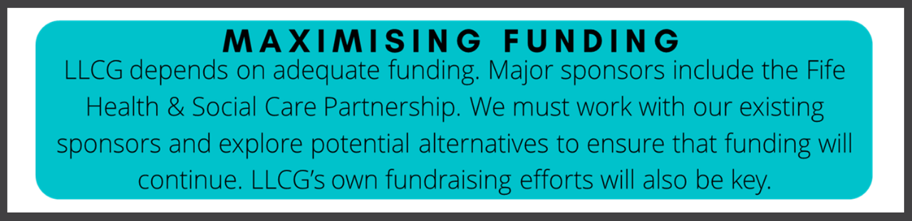
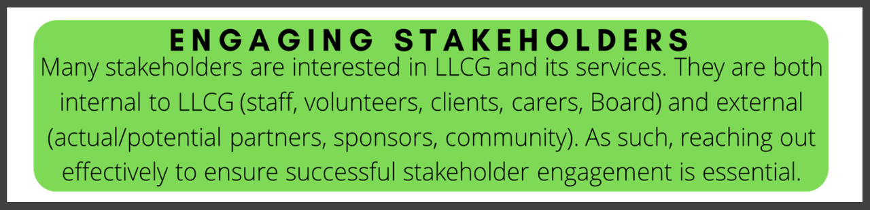
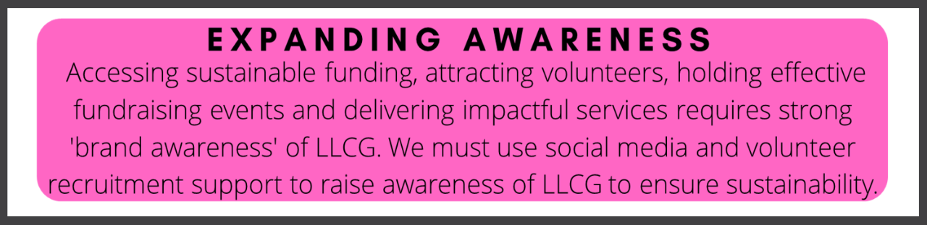
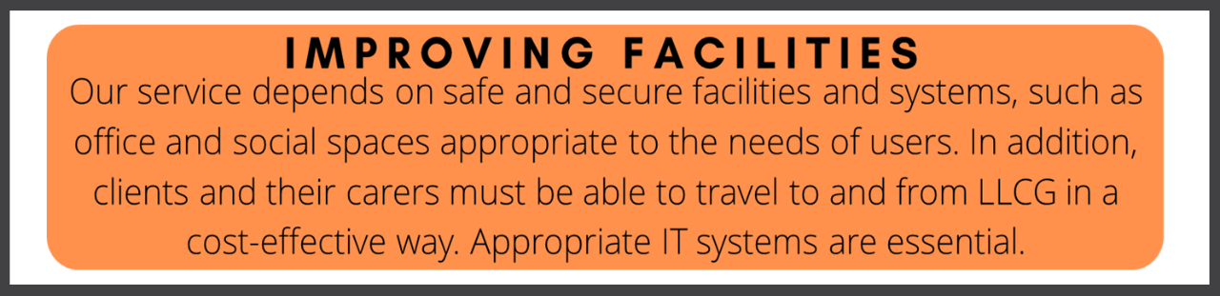
MEETING GROWING DEMAND
LLCG’s value is recognised by its stakeholders. Within the context of an expanding ageing population and an increasing dementia support need, we must balance our efforts between day-care services, with its attendant socialising benefits, and “one-to-one” services such as home visits.

Summary: The strategic priorities have different levels of urgency associated with them. The most urgent are developing management efficiency and maximising funding. These can be achieved using the funding databases and management efficiency tools. After that, the medium-term priorities should focus on engaging stakeholders and expanding awareness. Whilst meeting growing demand is a long-term priority.

Strategic and Evaluative Decision-Making Framework
This framework uses the SMART Goals model to breakdown strategic priorities, specify objectives, outline necessary resources and management inputs and create indicators for measuring our progress towards the strategic priorities. It is designed with evaluation and implementation in mind and is a flexible guide open to continuous amendments and improvements.

SMART Goals refers to ensuring objectives are specific (S), measurable (M), achievable (A), relevant (R) and time-bound (T). This ensures objectives are simple to plan within and easy to monitor and evaluate.

Six priorities are shown as highlights of the framework below:
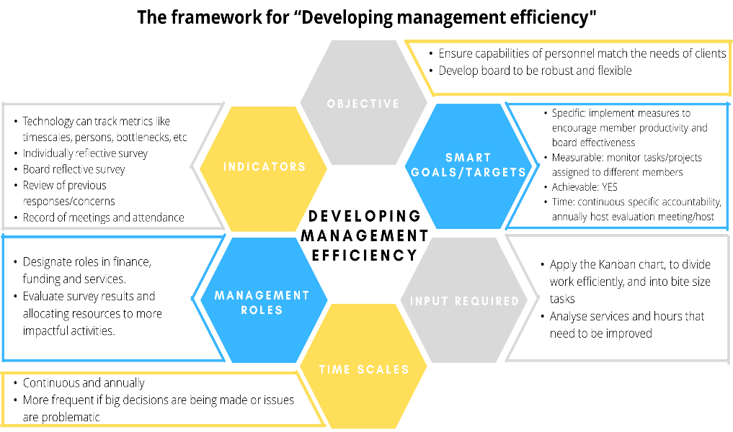
- Continuous and Annually
- More frequent if big decisions are being made or issues are problematic.
- Technology can track metrics like timescales, persons, bottlenecks
- Individually reflective survey
- Board reflective survey
- Review of previous responses concerns
- Record of Meetings & attendance
- Designate roles in finance, funding and services
- Evaluate survey results and allocating resources to more impactful activities
- Ensure capabilities of personnel match needs of clients
- Develop board to be robust and flexible
- Specific: Implement measures to encourage member productivity and board effectiveness
- Measurable: monitor tasks/projects assigned to different members
- Achievable: YES
- Time: continuous specific accountability, annually host evaluation meeting/host
- Apply the Kanban chart, to divide work efficiently, and into bite size tasks
- Analyse services and hours that need to be improved

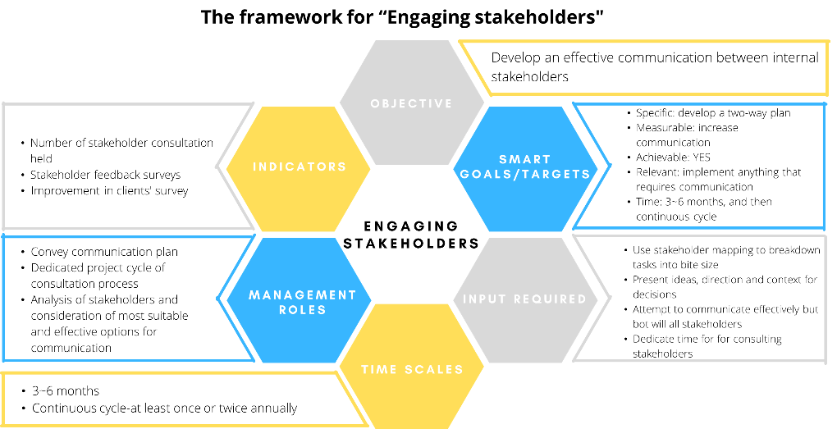
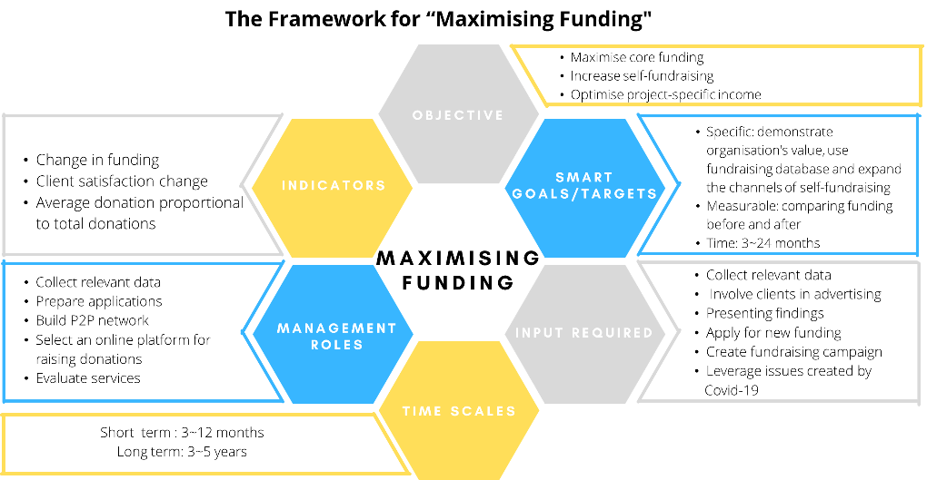

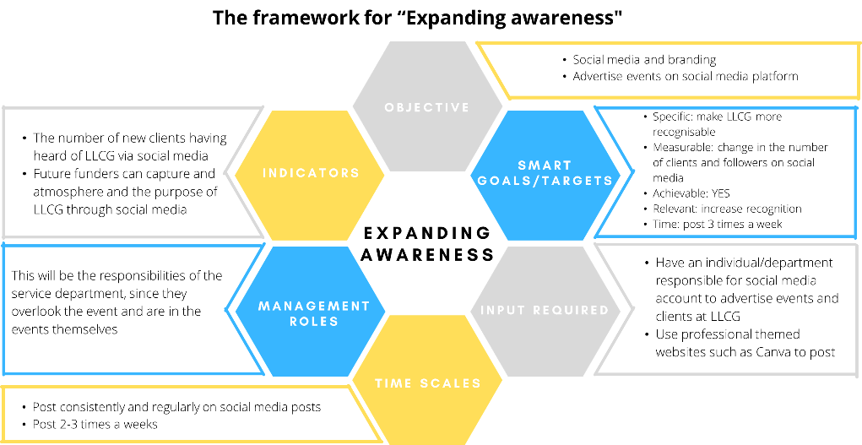
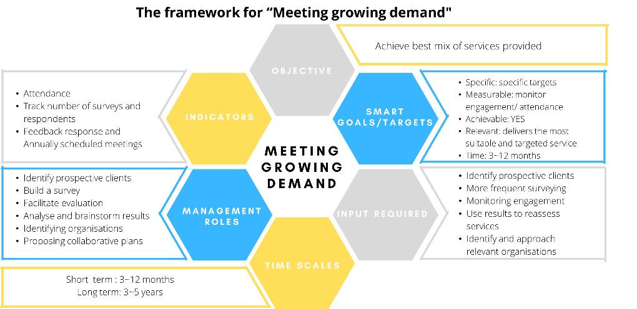

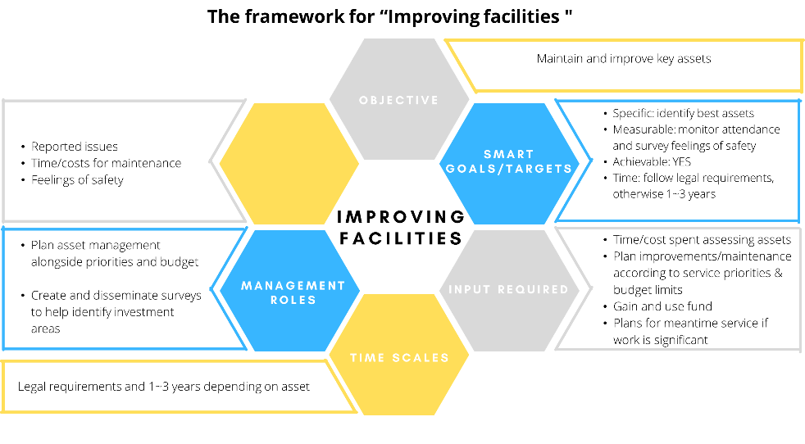

Summary: This framework offers a breakdown of strategic priorities into more specific and practical objectives. If used effectively, management will be more robust and LLCG’s progress will be more tangible. The template used, with further details, can be found in a separate document called the Evaluative Decision-Making Framework.

Conclusion

Summary
This strategic plan outlines LLCG’s direction between 2022 and 2027.

It explains LLCG, its purpose and values before exploring its services and structure.

The analysis pertinent to any organisation’s success is included and incorporated in structuring LLCG’s strategic priorities. This acts as a foundation for critically considering strategic options and suitable evaluation measures and steps. This must be an ongoing process throughout the strategic period and specific projects to help ensure progress is made and that LLCG is delivering on its mission.

The plan has also highlighted two urgent strategic areas that LLCG must focus on and develop:
- Developing Management Efficiency
- Maximising Funding
These priorities should be the key objectives for next strategic year as LLCG recovers from the pandemic.

Annexes

Contents
- Survey Insights
- PESTLE Template
- SWOT Template
- TOWS Template

A. Client/Carer Survey Insights
Graphs below highlight the key findings from the survey conducted in November 2021. All the results can be found in a separate Excel sheet.
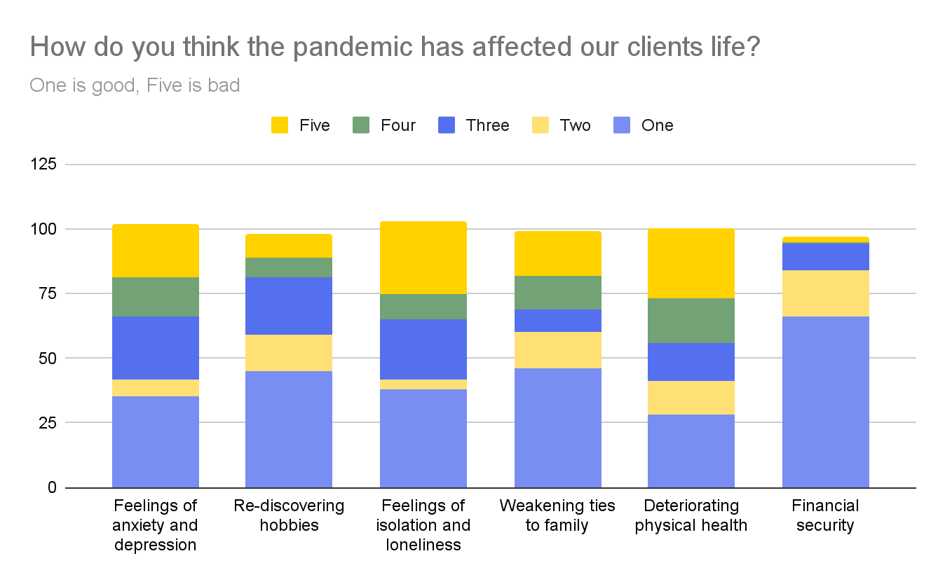

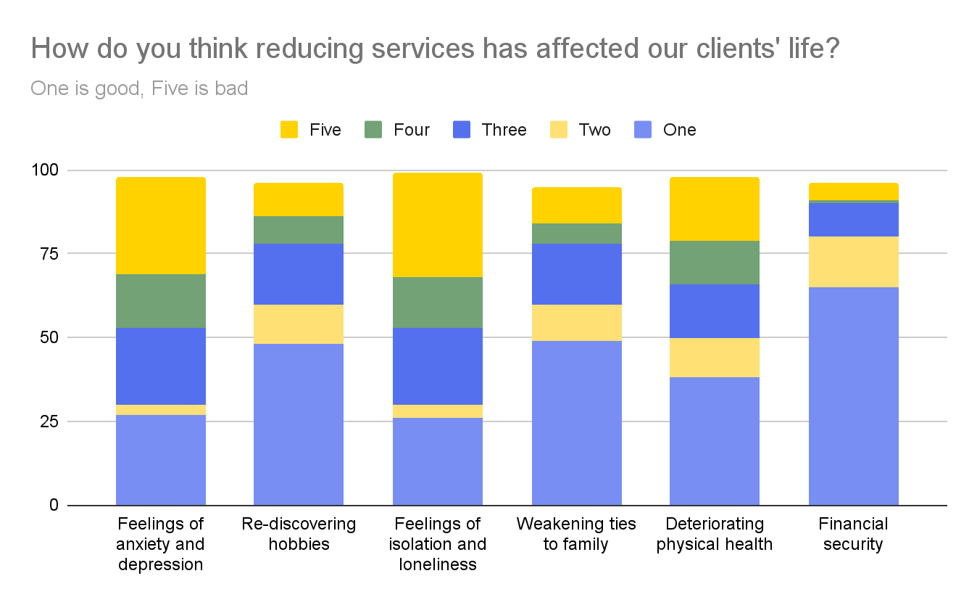

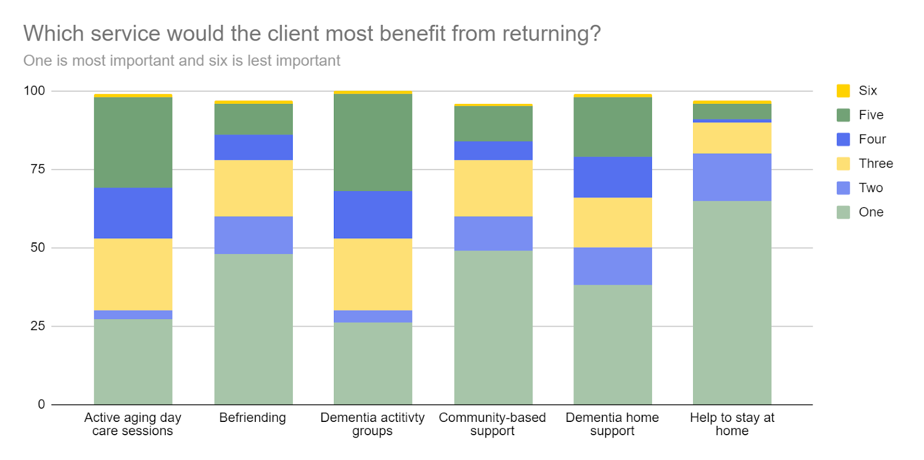

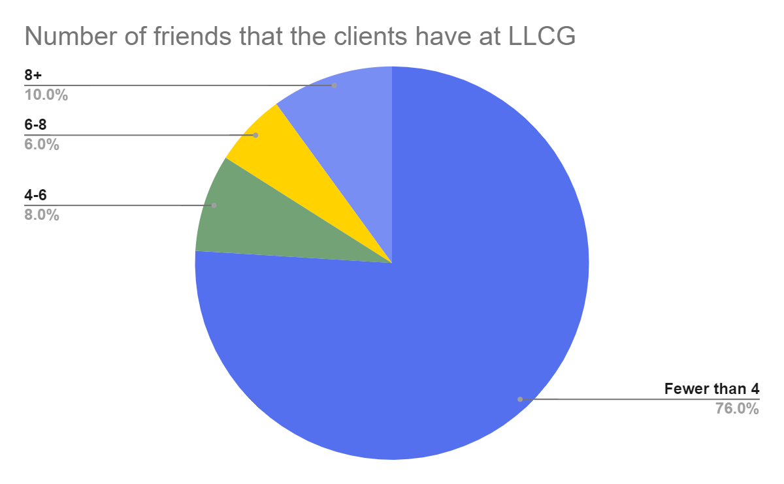

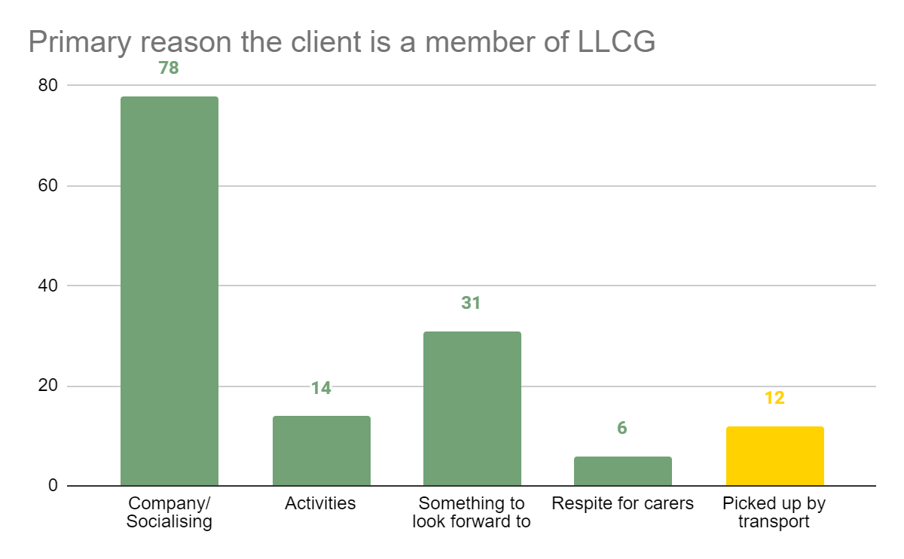
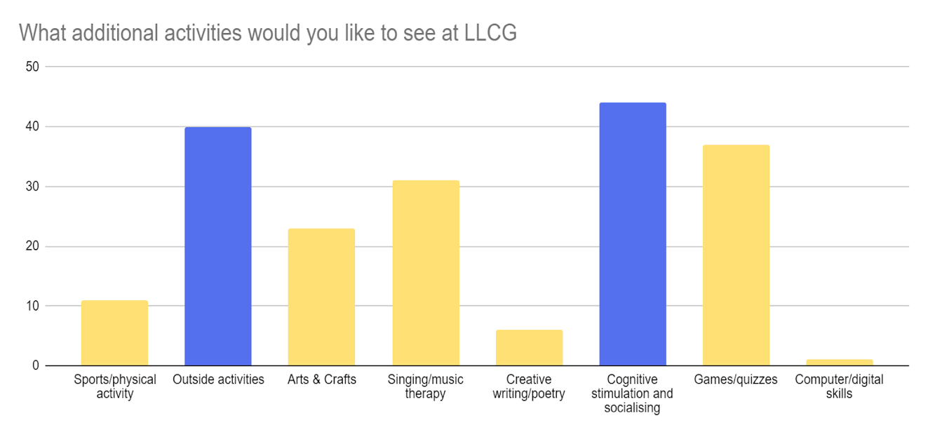
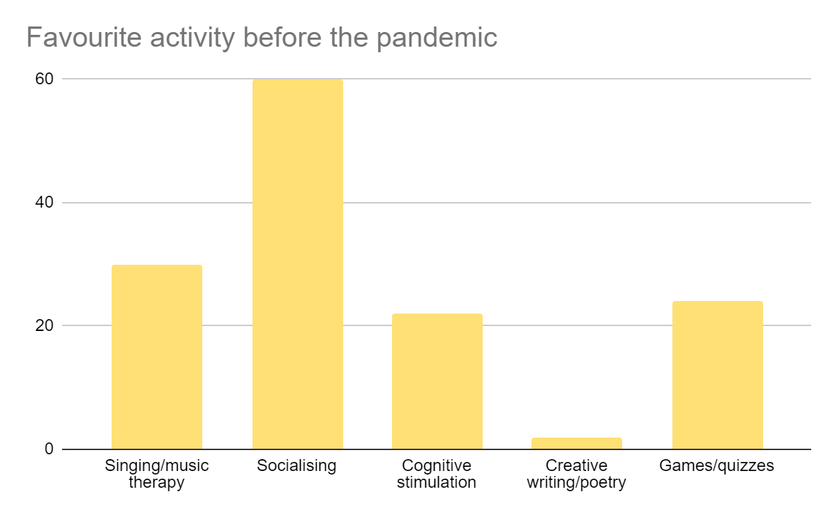

B. PESTLE Analysis Template
PESTLE analysis evaluates the external environment by breaking down opportunities and risks into Political, Economic, Social, Technological, Legal and Environmental factors, helping LLCG better understand the situation it operates in.

Factor | Summary
Political | - COVID-19 has been a political crisis for the older person healthcare industry.  - Increased pressure  - Opportunity for support  - Fife Health & Social Care Partnership is an external political funding source  - Expected to remain stable  - Guidelines are open to change
Economic | - COVID-19 badly damaged the UK economy - it is now recovering  - High government expenditure  - Opportunity for funding  - Bus companies have cut services  - Fewer transport options
Social | - 31% increase in over-75s by 2028  - Isolated living arrangements expected to increase  - Growing demand  - COVID-19 restrictions reducing  - Volunteering opportunities  - Family involvement
Technological | - Increasing reliance on technology for communication, marketing, operation processes etc across industries  - Increasing technological awareness across older people, but still low  - Low appetite from clients  - Opportunity for volunteer recruitment and training (potentially partnering with online training providers to reduce costs)
Legal | - COVID-19 restrictions might return  - Restrict service almost completely  - Unlikely to be as strict  - Minimum wage increases  - Cost burdens  - Regulations on volunteering qualifications
Environmental | - Global pressure for reducing energy consumption etc  - Low significance for LLCG  - Clients are not likely to demand it either

C. SWOT Analysis Template
SWOT analysis, which was also conducted by LLCG in the last strategic plan report, has been updated for the next strategic period. It demonstrates the current strengthens, weaknesses, opportunities and threats facing LLCG.

STRENGTHS | WEAKNESSES
- High quality service  - Solid reputation with funders  - Effective and committed staff and support volunteers  - Strong standing in the community  - Connections with carers  - Impressive response to COVID-19 impacts  - Support from clients  - Rebranding is more positively framed  - Robust value creation for accessing funding  - Key assets in premises and minibus | - High workload for staff  - Costly items (transport, training)  - Inadequate premises for increasing demand  - Limited engagement between staff and Board  - No structured fundraising plan  - Exposed management structure  - Insufficient marketing  - Strategic plan is hard to implement and evaluate  - Reliance on core funding  - Deficit making
OPPORTUNITIES | THREATS
- Community includes many organisations, like schools  - Many clients use other services too  - Rebranding presents opportunity raising LLCG’s profile  - Societal focus on older persons healthcare services  - Growing older persons population in Fife  - Reducing COVID-19 restrictions  - Enables travel  - Family involvement  - Technology-based training and qualification schemes  - Inexperienced young people  - Many potential funding sources | - Annual funding timeline restricts midterm planning  - Sponsor policies are liable to change  - Unexpected infrastructure investment through faults or safety issues  - Ageing volunteer force  - COVID-19:  - Reduced volunteer force  - Public transport routes have been cut, reliance on LLCG  - Restrictions might return  - Minimum wage increases squeeze costs  - Low appetite for technology integration from clients despite likely increasing need

D. TOWS Analysis Template
TOWS analysis combines PESTLE and SWOT analyses together to better inform LLCG about the environment it is facing. Surrounded by SWOT analysis, the essential part of the TOWS analysis lies in the central four cells.
The “STRENGTHS LEVERAGING OPPORTUNITIES” area focuses on how LLCG can leverage its strengths to reach potential opportunities.
The “OPPORTUNITIES OVERCOMING WEAKNESS” area describes how LLCG’s opportunities can remove its weaknesses.
The “STRENGTHS MINIMISING THREATS” area focuses on how strengths can be used to mitigate or remove the threats to LLCG, and, in some cases, how threats can be transformed to opportunities.
Finally, the “MINIMISING WEAKNESSES AND THREATS” area examines how LLCG can minimise its weaknesses and threats altogether.
 | INTERNAL FACTORS
 |  | STRENGTHS  1. High quality service  2. Effective and committed staff and support volunteers  3. Strong standing in the community  4. Connections with carers  5. Impressive response to COVID-19 impacts  6. Support from clients  7. Rebranding is more positively framed  8. Robust value creation for accessing funding  Key assets in premises and minibus | WEAKNESSES  1. Reliance on volunteers  High workload for staff  Costly items (transport, training)  2. Inadequate premises for increasing demand  3. Limited engagement between staff and Board  4. Not reaching all of the community  5. Ineffective management structure  6. Insufficient marketing  Strategic plan is hard to implement and evaluate  7. Reliance on core funding  Deficit making
EXTERNAL FACTORS | OPPORTUNITIES  1. Community includes many organisations, like schools  2. Many clients use other services too  3. Rebranding presents opportunity for marketing and fundraising  4. Social media presence  5. Societal focus on older persons healthcare services  6. Growing older population in Fife  7. Reducing COVID-19 restrictions  - Enables travel  - Family involvement  8. Technology-based  training and qualification schemes  9. Inexperienced young people | STRENGTHS LEVERAGING OPPORTUNITIES  1. Reputation and client demand can enable partnerships and collaborative projects with organisations (age or otherwise)  2. Use community standing to build social media presence  3. Use reputation and need for volunteers to attract young volunteers who need work experience (market it as such)  4. Develop initiatives to reconnect clients to their families | OPPORTUNITIES OVERCOMING WEAKNESS  1. Use internet schemes to support training and qualifications and reduce costs  2. Use marketing projects, and particularly social  media, to attract young volunteers to help develop  a stronger “brand” and management team  3. Use reputation, rebranding and community  standing to promote LLCG, raise funds and spread financial risk  4. Use reputation to access low cost/free premises  5. Reassess premises utilisation  6. Partnerships can hold events together to save money, learn how they fundraise, manage themselves, advertise themselves and reach the community
 | THREATS  1. Annual funding timeline restricts midterm planning  2. Sponsor policies are liable to change  3. Unexpected infrastructure investment through faults or safety issues  4. Ageing volunteer force  5. COVID-19:  - Reduced volunteer force  - Public transport routes  have been cut, reliance  on LLCG  -Restrictions might return  6. Minimum wage increases squeeze costs  7. Low appetite for technology integration from clients despite likely increasing need | STRENGTHS MINIMISING THREATS  1. Potential for other funding sources enables midterm planning and reduces impact of policy changes  2. Use reputation and need for volunteers to attract young volunteers who need work experience (market it as such)  3. Consider agreements with taxi companies to help reduce costs and pressure on LLCG  4. Scenario plan proactively to help guide LLCG during another lockdown | MINIMISING WEAKNESSES AND THREATS  1. Including some staff, clients and/or carers in management meetings  2. Restructure approach to management and project implementation  3. Deliberate on funding options to spread risk and fill deficit  4. Consider external cleaning company/making cleaning part of volunteering duties to reduce impact of minimum wage increases  5. Despite lack of appetite, technology use in the older persons is growing. Towards end of strategic period, it might be possible to utilise and create new services and channels.

Fife Health and Social Care Partnership website

